Rebecca Barnard: (b: 1961 UK)

web: www.rebeccabarnardart.com

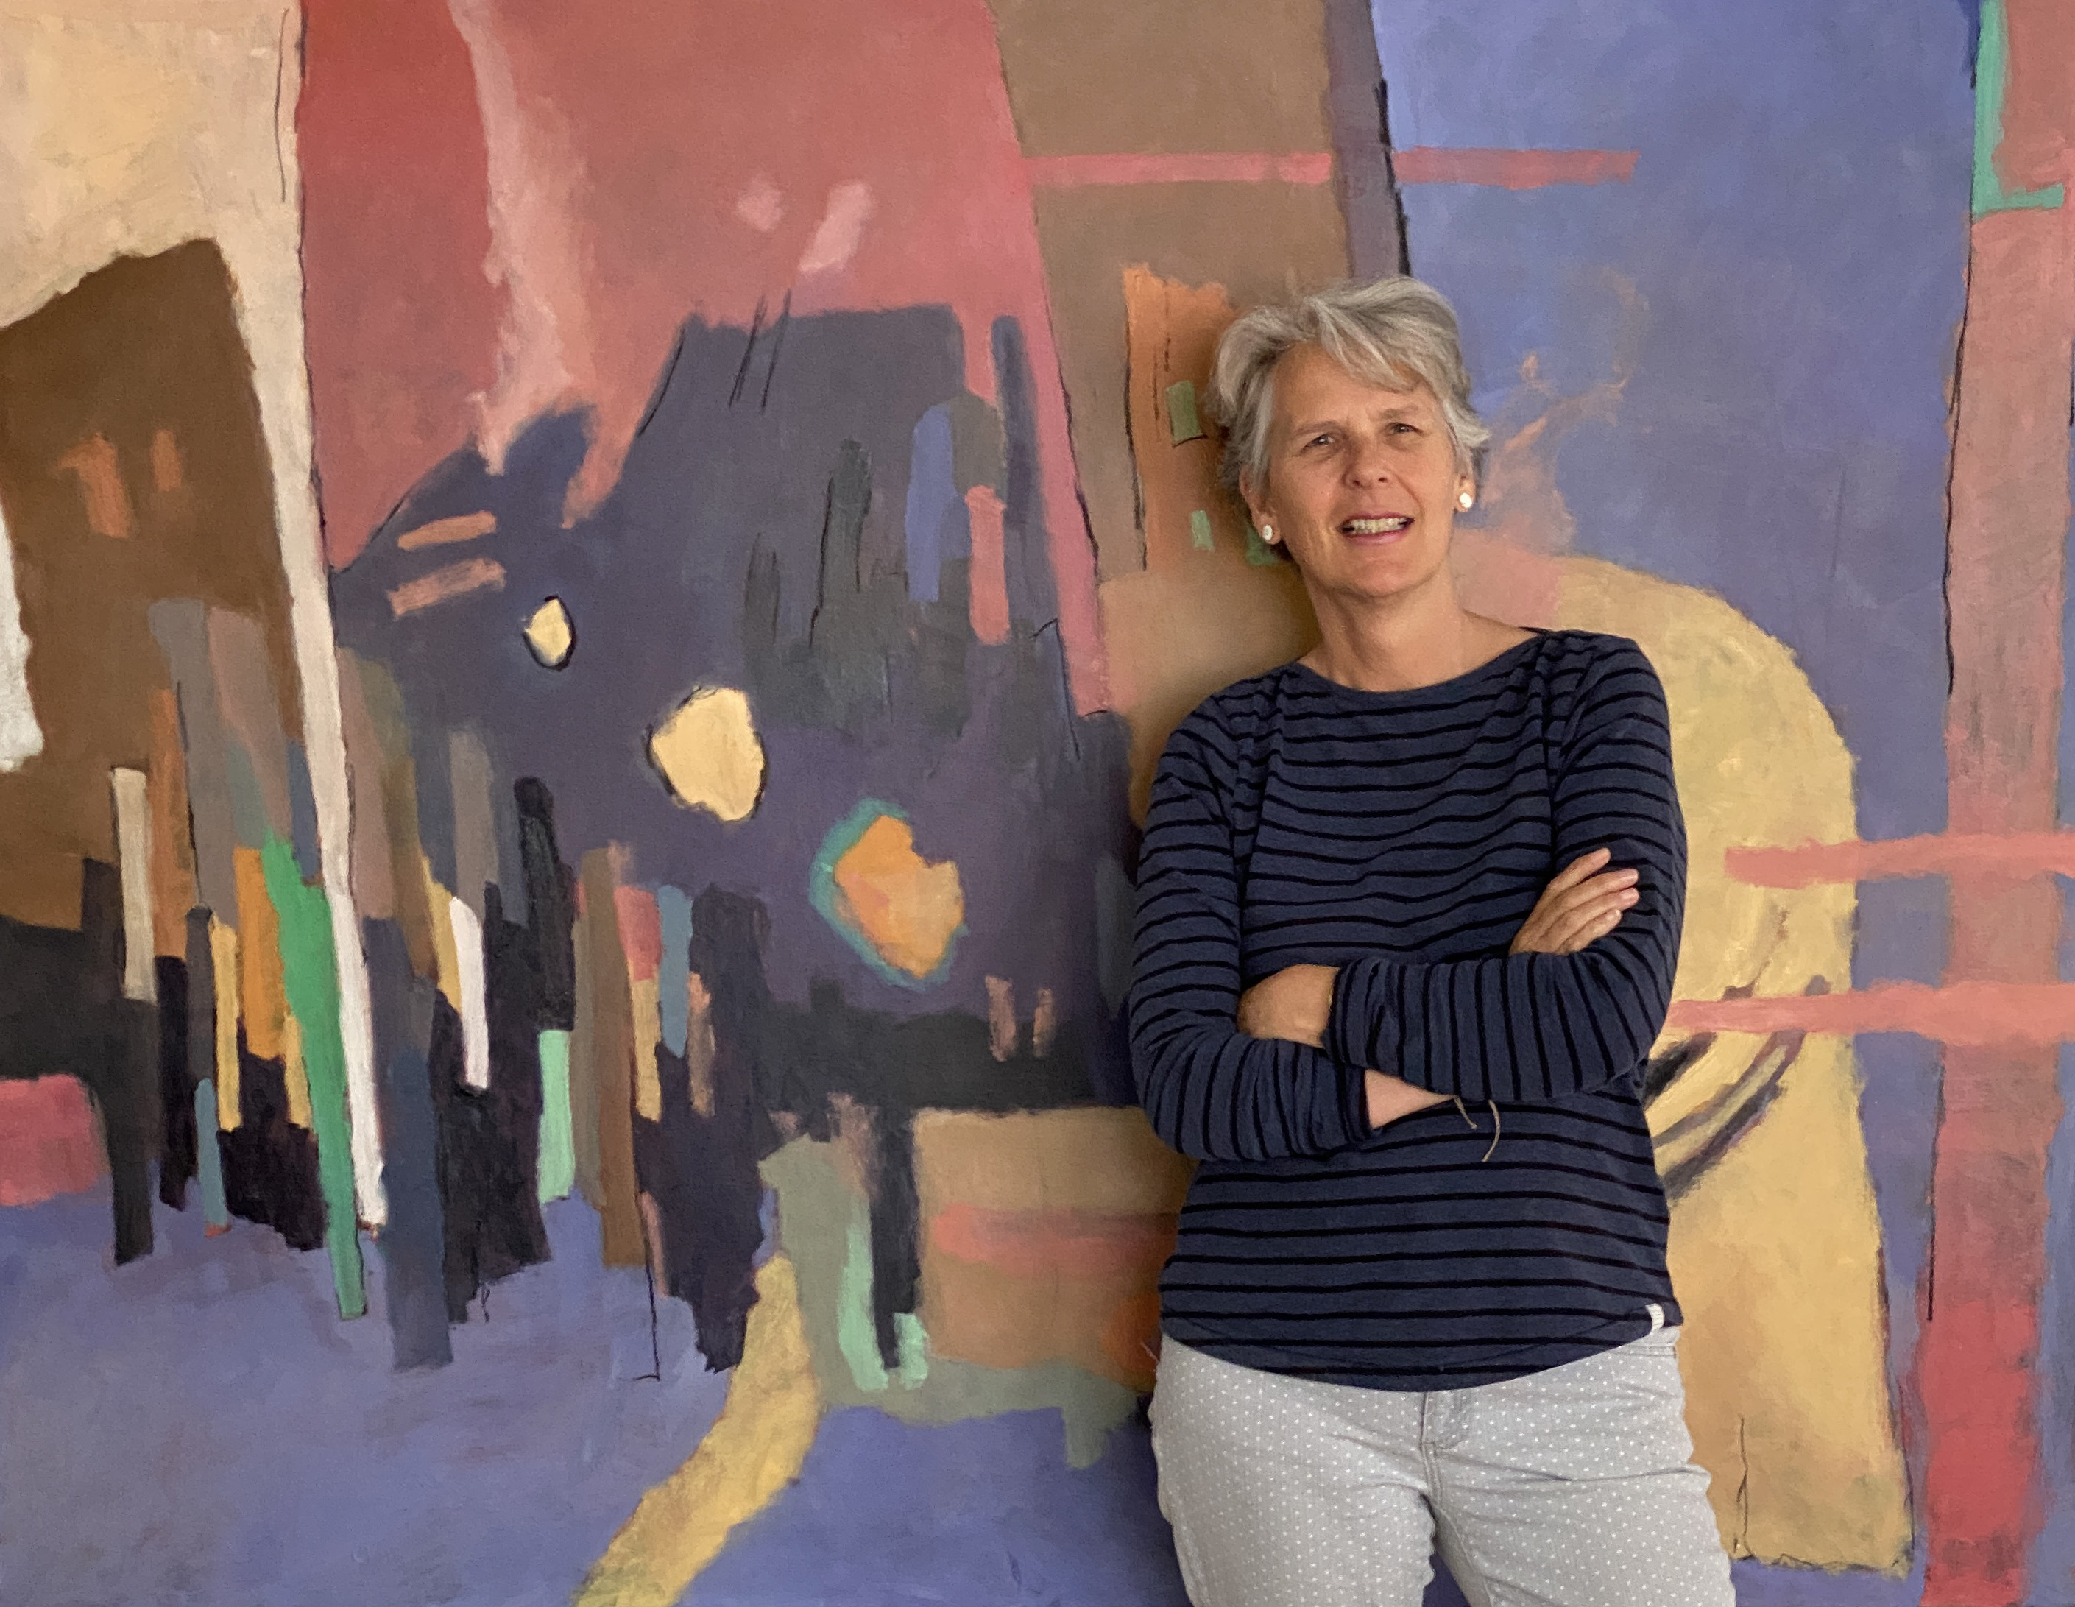

Rebecca Barnard is based in Somerset and has an MA in Fine Art with Distinction from Falmouth School of Art 2023/24.

Her practice predominately incorporates intuitive abstract painting and organic sculpture. It can take the form of both multi media installations or single media projects. She enjoys the play between abstraction and figuration. Subject matter is often dictated through intuitive and experimental process.

Her overarching concerns are focussed on the dance between balance and fragility, that teetering place we negotiate on a daily basis. Her process and outcome for both painting and 3D works, reflects that fragile place where balance and chaos meet.

Rebecca exhibits throughout the UK and her work is now in private collections across the world, including USA, South Africa, Australia, Austria and Egypt. She has been selected for many prestigious exhibitions including the Bath Society of Artists, Royal West of England Academy, The Society of Women Artists and others.

Rebecca Barnard also teaches oil painting and cold wax technique as part of the educational programme within Heritage Courtyard Studios in Wells

Solo and Two Person Exhibitions  2023 "The Machinery has Started"  The Loft Gallery, Wells (solo)  2022 "Catharsis" Heritage Courtyard  Gallery, Wells (solo)  2021 "Inside Out", Wells 2 man show  2014 Cambridge Contemporary Art (Two Person)  2011 Langton Street Gallery, Chelsea (solo)  2010 Cambridge Contemporary Art (solo)  2007 Cambridge Contemporary Art (solo)  2002 The Lennox Gallery, Fulham (solo)  Selection of Mixed Exhibitions  2024 Bath Society of Artists, Victoria Gallery, Bath  2024 The Society of Women Artists, Mall Galleries  2024 South West Academy (SWAc)  (Winner, Brownston Prize 2024)  2024 The Atkinson Gallery, Somerset  2019, 21, 22, 23 Bath Society of Artists, Victoria Gallery, Bath  2021, 22 Royal West of England Academy, Bristol  2022 The Salthouse Gallery, St Ives  2001 – 2021 Cambridge Contemporary Art  2020, 21 Society of Women Artists  2020 St Ives Contemporary Art  2019 "Re-Formation" The Bishop's Palace, Wells  2018, 19, 20 The George Farnham Gallery, Saxmundham |  | 2017 – 2021 The Russell Gallery, London SW15  2016 – present Heritage Courtyard Gallery  2014 – 2016 The Russell Gallery, London  2007 – 2012 Thompson's Gallery, Aldeburgh  2008 – 2012 Broadway Modern, Broadway  2009 Sadler Street Gallery, Wells  2008 & 2009 Mall Galleries (Art for Youth)  2005 – 2006 Lacy Road Gallery, London  2003 Enid Lawson Gallery, London  2000 Artmonsky Arts, London  2000 Wills Art Warehouse, London

